AIM

Design and implement a stack using an array and demonstrate its working with nessarry input,display the appropriate output.

ALGORTHIM:

Step 1: Include all the header files which are used the program and define a constant size with a specific value.

Step 2:Declare all the functions used in a stack implementation.

Step 3:Create a one dimensional array with fixed size.

Step 4:Define a integer value “top” and initialize with -1.

Step 5:In main method,display,menu with list of operations and make a suitable function calls to perform operations selected by user on the stack.

TO PUSH:

Step 1:Chech wheather the stack is full

Step 2:If it is full then it displays “stack is full insertion is not possible”and terminates the function.

Step 3:If it is not full,then increment the top value by one and set the stack to value.

TO POP:

Step 1:check wheather the stack is empty

Step 2:If it is empty then it will display “stack is empty” and the program terminates.

Step 3:If not empty,then define a variable ‘I’ and initialize with top.

Step 4:Repeat the above experiments until the I value become zero.

PROGRAM:

#include<stdio.h>//standard input output header file//

#include<stdlib.h>//standard library header file//

#define size 5//initializing the array size to 5//

void push();//push function//

void pop();//pop function//

void display();//display function//

int top=-1,inp_arr[size],i;//initializing the top value to the -1//

int main()//main function//

{

int choice;//declaring the choice//

while(1)//checks the condition//

{

printf("operation performed by the stack");//prints the statement//

printf("\n 1.push \n 2.pop \n 3.display \n 4.exit \n");//prints the functions//

printf("enter the operation performed by the stack\n");//print the statement//

scanf("%d",&choice);//scans the input and places the value into the choice//

switch(choice)//scans the condition and enters into the case when it satisfies//

{

case 1:push();//prints the case 1 when the condition is 1//

break;

case 2:pop();//prints the case 2 when the condition is 2//

break;

case 3:display();//prints the case 3 when the condition is 3//

break;

case 4:exit(0); //come out of the loop//

default:printf("invalid entry\n");//prints the value//

}

}

return 0;

}

void push()

{

int x;//declaring the x//

if(top==size-1)//checks the condition//

{

printf("overflow\n");//prints the value when it satisfies//

}

else

{

printf("enter the value to be inserted\n");

scanf("%d",&x);

top=top+1;//increment by 1//

inp_arr[top]=x;

}

}

void pop()

{

if(top==-1)//checks the condition//

{

printf("underflow\n");

}

else

{

printf("popped element is %d\n",inp_arr[top]);

top=top-1;//decrement//

}

}

void display()

{ int i;

if(top>-1)//checks the condition//

{

printf("elementes in the stack r \n");

for(i=top;i>-1;i--)

{

printf("%d\n",inp_arr[i]);

}

}

else

{

printf("stack is empty\n");

}

}

SCREENSHOT OF THE OUTPUT:

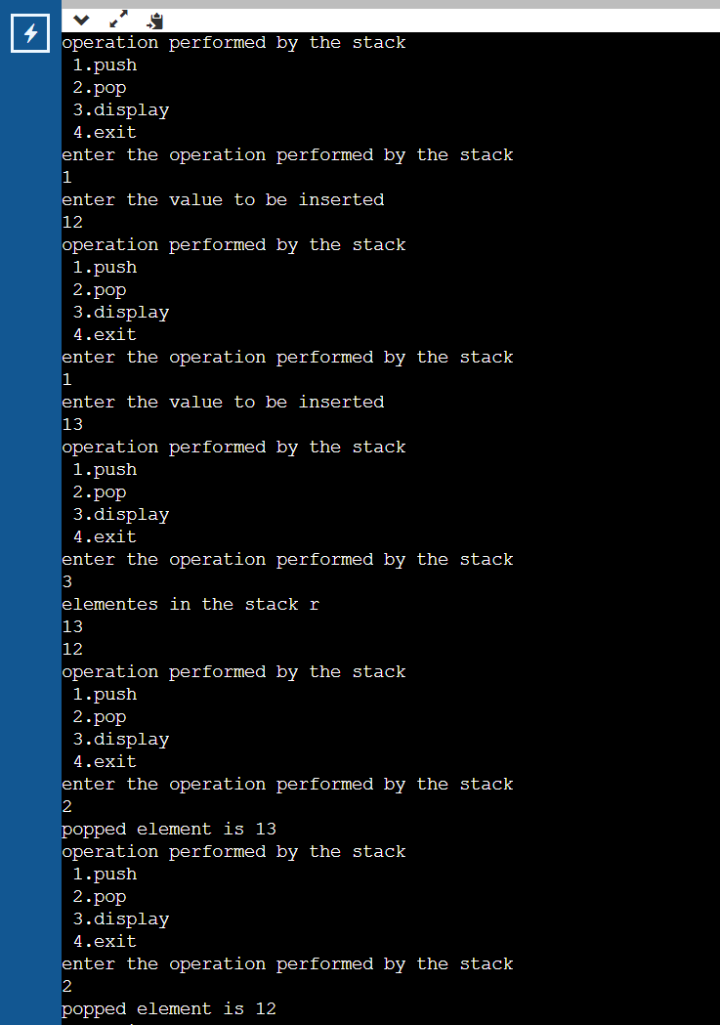

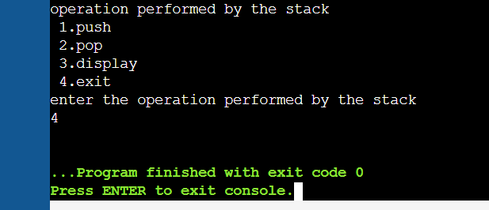

GITHUB LINK:

https://github.com/Rithwik314/DS-LAB-PROGRAMS/upload/main